Personal Health & Medication Tracker System

Group Members:
Faith Wenchie C. Flor 2024-1810-A
Jirah Joy E. Pardos 2024-2718-A
Dan Gero T. Villasor 2024-9088-A

Course, Year & Section:
BS INFO TECH 2C

Mr. Kenny Saylo
Course Instructor

June 21, 2026

Final Project | Section 2 – System Overview | DBSYS 1

Personal Health & Medication Tracker System
The Personal Health and Medication Tracker System is a database driven web application that helps individuals record and monitor daily health metrics and manage medication schedules. Users can log vital signs such as blood pressure, weight, and blood sugar with timestamps and optional notes. The system stores medication profiles with details like dosage, frequency, and start and end dates, and it generates reminders so doses are not missed.
The application provides simple analytics and visual summaries to reveal trends and progress toward goals. Dashboards and time series charts make it easy to review recent measurements and adherence history. Users can export concise reports for clinicians and optionally grant caregivers limited access to receive alerts for missed doses or critical values.
Privacy and security are built into the design with secure authentication, encrypted storage for sensitive fields, and role based access control. Background schedulers handle reminder delivery and retry logic for failed notifications while immutable logs record critical actions for traceability and auditing.
Overall, the system aims to improve medication adherence, simplify communication with healthcare providers, and give users a reliable place to manage their daily health information. Success is measured by reliable logging and reminders, accurate charts and exports, and positive results from basic usability and security testing.

Final Project | Section 3 – ERD (Entity-Relationship Diagram) | DBSYS 1

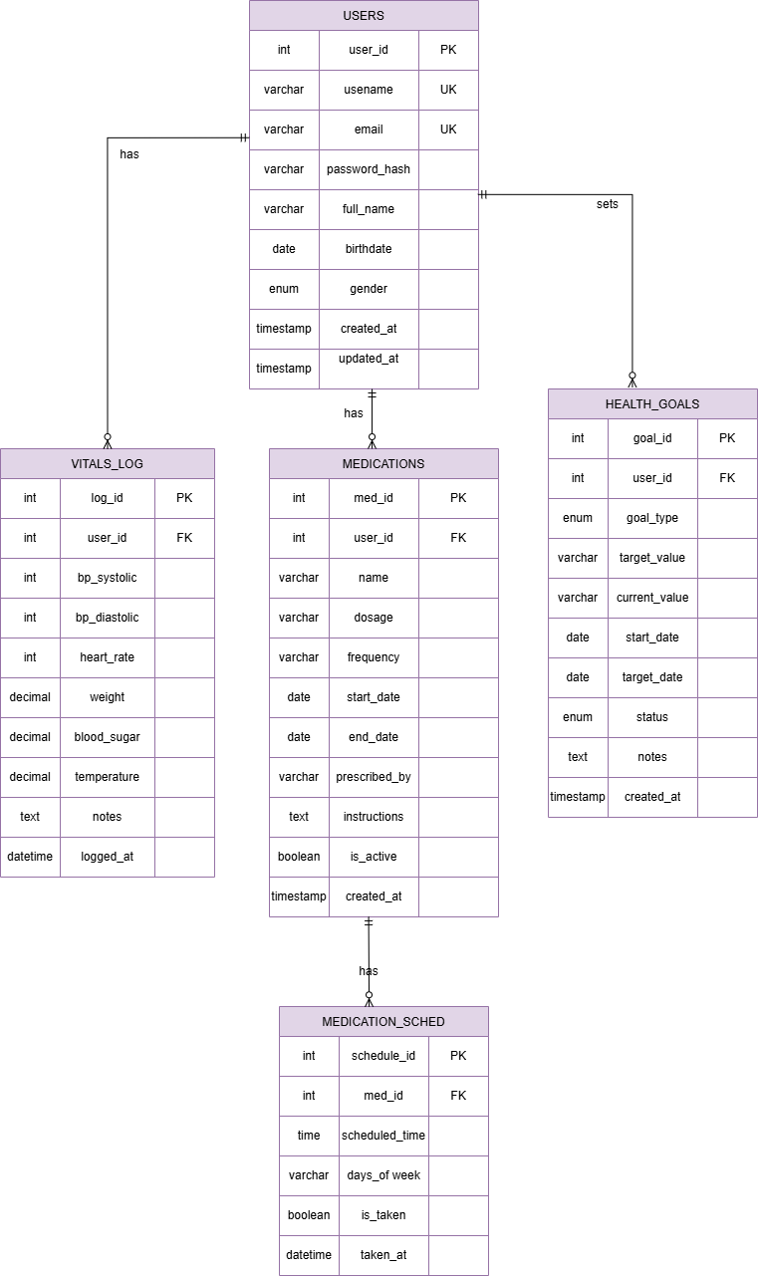
Final Project | Section 4 – Data Dictionary | DBSYS 1
USERS
Field Name | Data Type | Constraints | Description
user_id | INT | PK; AUTO_INCREMENT | Unique identifier for each system user
username | VARCHAR(50) | UK; NOT NULL | Unique login username
email | VARCHAR(100) | UK; NOT NULL | User's email address for contact and login
password_hash | VARCHAR(255) | NOT NULL | Hashed password; never store plain text
full_name | VARCHAR(100) | NOT NULL | User's full name
birthdate | DATE | NULL | User's date of birth
gender | ENUM | NULL; Values: Male; Female; Other | User gender
created_at | TIMESTAMP | DEFAULT CURRENT_TIMESTAMP | Account creation timestamp
updated_at | TIMESTAMP | DEFAULT CURRENT_TIMESTAMP ON UPDATE | Last profile update timestamp

VITALS_LOG
Field Name | Data Type | Constraints | Description
log_id | INT | PK; AUTO_INCREMENT | Unique identifier for each vitals entry
user_id | INT | FK → USERS(user_id) | Links vitals entry to a specific user
blood_pressure_systolic | INT | NULL | Systolic blood pressure reading (mmHg)
blood_pressure_diastolic | INT | NULL | Diastolic blood pressure reading (mmHg)
heart_rate | INT | NULL | Heart rate in beats per minute
weight | DECIMAL(5,2) | NULL | Weight in kilograms
blood_sugar | DECIMAL(5,2) | NULL | Blood glucose level in mg/dL
temperature | DECIMAL(4,1) | NULL | Body temperature in Celsius
notes | TEXT | NULL | Additional notes or symptoms
logged_at | DATETIME | DEFAULT CURRENT_TIMESTAMP | Timestamp of when vitals were logged

MEDICATIONS
Field Name | Data Type | Constraints | Description
medication_id | INT | PK; AUTO_INCREMENT | Unique identifier for each medication
user_id | INT | FK → USERS(user_id) | Links medication to a specific user
name | VARCHAR(100) | NOT NULL | Name of the medication
dosage | VARCHAR(50) | NOT NULL | Dosage strength (e.g., 5mg; 500mg)
frequency | VARCHAR(50) | NOT NULL | How often to take (e.g., Once daily; Twice daily)
start_date | DATE | NOT NULL | Date medication was started
end_date | DATE | NULL | Date medication ends or was discontinued
prescribed_by | VARCHAR(100) | NULL | Name of prescribing healthcare provider
instructions | TEXT | NULL | Special instructions for taking medication
is_active | BOOLEAN | DEFAULT TRUE | Whether medication is currently active
created_at | TIMESTAMP | DEFAULT CURRENT_TIMESTAMP | Record creation timestamp

HEALTH_GOALS
Field Name | Data Type | Constraints | Description
goal_id | INT | PK; AUTO_INCREMENT | Unique identifier for each health goal
user_id | INT | FK → USERS(user_id) | Links goal to a specific user
goal_type | ENUM | NOT NULL; Values: Weight; Blood Pressure; Blood Sugar; Exercise; Other | Type of goal
target_value | VARCHAR(50) | NOT NULL | Goal target (e.g., 65kg; 120/80; 30min/day)
current_value | VARCHAR(50) | NULL | Current progress toward goal
start_date | DATE | NOT NULL | Date medication was started
target_date | DATE | NULL | Target completion date
status | ENUM | DEFAULT 'Not Started'; Values: Not Started; In Progress; Achieved; Abandoned | Current status of the goal
notes | TEXT | NULL | Additional notes about the goal
created_at | TIMESTAMP | DEFAULT CURRENT_TIMESTAMP | Record creation timestamp

MEDICATIONS_SCHEDULE
Field Name | Data Type | Constraints | Description
schedule_id | INT | PK; AUTO_INCREMENT | Unique identifier for each schedule entry
medication_id | INT | FK → MEDICATIONS(medication_id) | Links schedule to a specific medication
scheduled_time | TIME | NOT NULL | Time of day to take medication
days_of_week | VARCHAR(20) | DEFAULT 'Daily' | Days to take; e.g., Daily; Weekdays; Weekends
is_taken | BOOLEAN | DEFAULT FALSE | Whether dose has been taken today
taken_at | DATETIME | NULL | Timestamp when dose was marked as taken

Final Project | Section 5 – SQL Script Summary | DBSYS 1

A. STORED PROCEDURES

Procedure Name: AddUser
Purpose:
The AddUser procedure is responsible for adding a new user to the users table. Before inserting the record, it checks whether a user with the same email address or username already exists in the database. If a duplicate record is found, the insertion is prevented; otherwise, the new user is successfully added.
Input Parameters:
Parameter | Description
p_username | User's chosen username
p_email | User's email address
p_password_hash | Hashed user password
p_full_name | User's full name
p_birthdate | User's date of birth
p_gender | User's gender (Male, Female, Other)

Output:
Adds the newly added user to the users table, as long as the record does not exist yet.
Procedure Name: AddVital

Purpose:
The AddVital procedure is responsible for adding a new vital sign record to the vitals_log table. Before inserting the record, it validates that the user exists. After insertion, it automatically updates the current_value of any matching health goals for the user. If the user has a weight goal, it updates with the weight value; if there's a blood pressure goal, it updates with the systolic/diastolic reading; and if there's a blood sugar goal, it updates with the blood sugar value. The procedure ensures that only goals with status 'Not Started' or 'In Progress' are updated.

Input Parameters:
Parameter | Description
p_user_id | ID of the user logging the vitals
p_systolic | Systolic blood pressure reading (mmHg)
p_diastolic | Diastolic blood pressure reading (mmHg)
p_heart_rate | Heart rate in beats per minute
p_weight | Weight in kilograms
p_blood_sugar | Blood glucose level in mg/dL
p_temperature | Body temperature in Celsius
p_notes | Additional notes or symptoms

Output:
Inserts a new vital record into the vitals_log table and updates matching health goals with the current values.

Procedure Name: AddMedication
Purpose:
The AddMedication procedure is responsible for adding a new medication to the medications table. Before inserting the record, it validates that the user exists and checks if the medication name already exists for that user. If a duplicate record is found, the insertion is prevented; otherwise, the new medication is successfully added.

Input Parameters:
Parameter | Description
p_user_id | ID of the user
p_name | Name of the medication
p_dosage | Dosage strength (e.g., 5mg, 500mg)
p_frequency | How often to take (e.g., Once daily, Twice daily)
p_start_date | Date medication was started
p_end_date | Date medication ends or was discontinued
p_prescribed_by | Name of prescribing healthcare provider
p_instructions | Special instructions for taking medication
p_is_active | Whether medication is currently active

Output:
Adds the newly added medication to the medications table, as long as the record does not exist yet.

Procedure Name: AddSchedule
Purpose:
The AddSchedule procedure is responsible for adding a new medication schedule entry to the medications_schedule table. Before inserting the record, it validates that the medication exists and is active, and checks if a schedule already exists for the same medication at the same time. If a duplicate record is found, the insertion is prevented; otherwise, the new schedule entry is successfully added.
Input Parameters:
Parameter | Description
p_medication_id | ID of the medication
p_scheduled_time | Time of day to take medication
p_days_of_week | Days to take (e.g., Daily, Weekdays, Weekends)
Output:
Adds the newly added schedule entry to the medications_schedule table, as long as the record does not exist yet.

Procedure Name: AddHealthGoal
Purpose:
The AddHealthGoal procedure is responsible for adding a new health goal to the health_goals table. Before inserting the record, it validates that the user exists and checks if a similar goal already exists for that user. If a duplicate record is found, the insertion is prevented; otherwise, the new goal is successfully added.
Input Parameters:
Parameter | Description
p_user_id | ID of the user
p_goal_type | Type of goal (Weight, Blood Pressure, Blood Sugar, Exercise, Other)
p_target_value | Goal target (e.g., 65kg, 120/80, 30min/day)
p_current_value | Current progress toward goal
p_start_date | Date goal was started
p_target_date | Target completion date
p_status | Current status of the goal
p_notes | Additional notes about the goal
Output:
Adds the newly added goal to the health_goals table, as long as the record does not exist yet.

Procedure Name: MarkDoseTaken
Purpose:
The MarkDoseTaken procedure is responsible for marking a medication dose as taken or resetting it to not taken. It validates that the schedule entry belongs to the specified user and updates the is_taken flag and taken_at timestamp accordingly.
Input Parameters:
Parameter | Description
p_schedule_id | ID of the schedule entry
p_user_id | ID of the user marking the dose
p_mark_taken | 1 to mark as taken, 0 to reset to not taken
Output:
Updates the medications_schedule table by setting is_taken and taken_at fields.

B. DATABASE VIEW

View Name: health_summary
Purpose:
The health_summary view provides an aggregated health summary for all users in the system. It combines data from the users, vitals_log, medications, health_goals, and medications_schedule tables to display comprehensive health metrics for each user. The view is designed for administrative reporting and monitoring purposes, allowing administrators to see a high-level overview of all users' health activities.
Fields Returned:
Field | Description
- user_id | Unique identifier of the user
- full_name | Full name of the user
- total_vitals_entries | Total number of vitals logged by the user
- total_medications | Total active medications of the user
- total_goals | Total health goals of the user
- pending_doses | Number of pending doses for the user
- last_vital_log | Timestamp of the most recent vital log
- vitals_7days | Number of vitals entries in the last 7 days
- adherence_rate | Medication adherence rate for the last 7 days
Benefits:
- Simplified queries by joining five tables into one ready-to-use view
- Improved readability and consistency across all reporting pages
- Fast dashboard updates with pre-computed aggregated data
- Easy monitoring of all users' health activities

C. JOIN Query
Purpose:
Combines medication schedule information with medication details to display a complete view of a user's daily medication schedule. This query joins the medications_schedule table with the medications table to show the medication name, dosage, frequency, and scheduled times together. The query is filtered to show only active medications for the logged-in user.
Tables Involved:
- MEDICATIONS_SCHEDULE
- MEDICATIONS

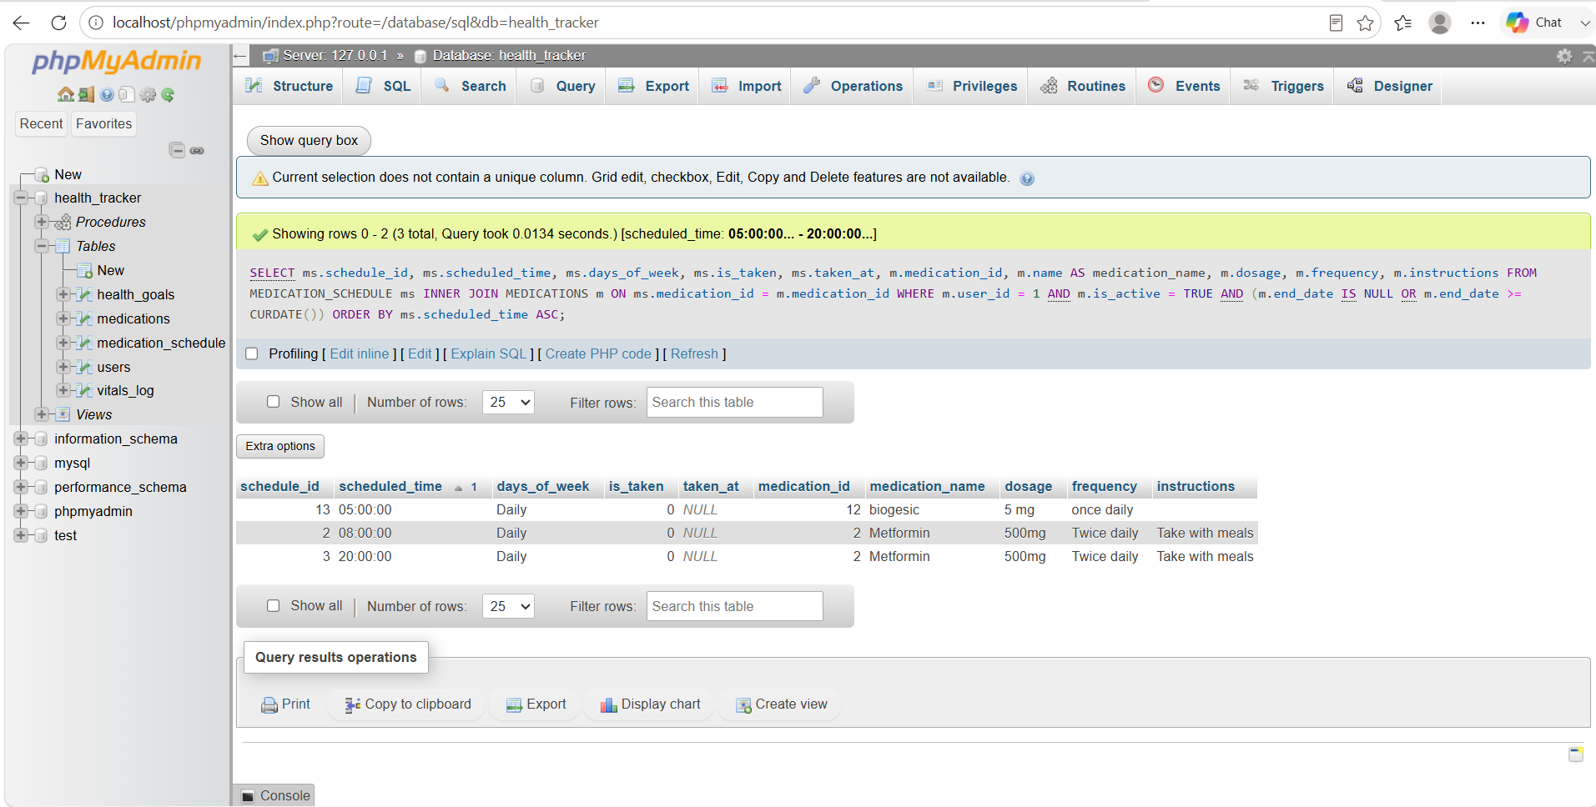
Join Type: INNER JOIN
Usage: Used in the Medication Schedule page to display the user's daily medication schedule with all relevant medication details.

D. Aggregate Query with GROUP BY
Purpose:
Calculates summary statistics for health goals grouped by goal type. This query shows how many goals each user has by type, how many have been achieved, and how many are still in progress. This provides users with a quick overview of their health goal progress across different categories.
Functions Used:
- COUNT() - Counts total goals per type
- SUM() with CASE - Counts achieved and in-progress goals
- GROUP BY - Groups results by goal type
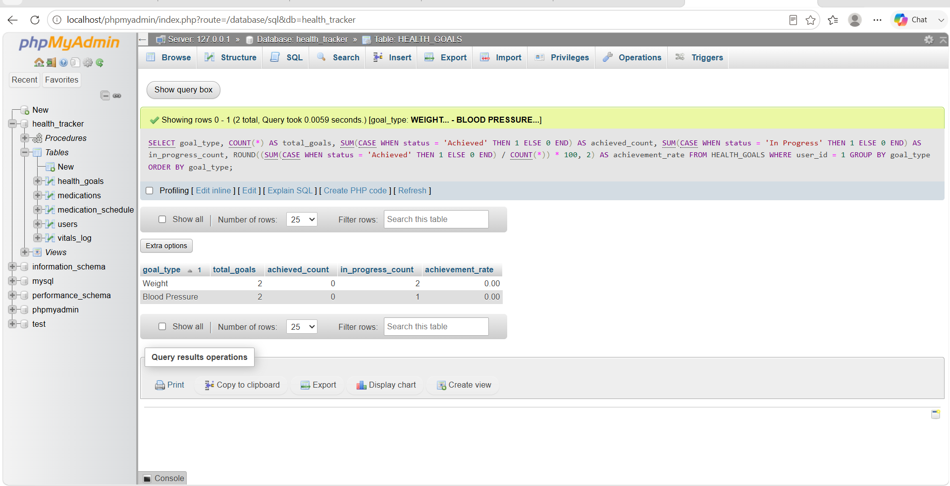
Usage: Used on the Health Goals page to show a summary of goals grouped by type.

E. Subquery (Correlated Subquery)
Purpose:
Identifies vital sign readings where the systolic blood pressure is above the user's personal average. This is a correlated subquery because the inner query references the outer query's user_id. The query shows the user's full name, all vital details, and specifically highlights readings that are elevated compared to their average.
Parent Query: Retrieves all vital log entries for a specific user along with their full name.
Child Query: Calculates the average systolic blood pressure for that user.
SELECT
v.log_id,
v.blood_pressure_systolic,
v.blood_pressure_diastolic,
v.heart_rate,
v.weight,
v.blood_sugar,
v.temperature,
v.logged_at,
u.full_name
FROM VITALS_LOG v
JOIN USERS u ON v.user_id = u.user_id
WHERE v.user_id = 1
AND v.blood_pressure_systolic > (
SELECT AVG(blood_pressure_systolic)
FROM VITALS_LOG
WHERE user_id = v.user_id
)
AND v.logged_at >= DATE_SUB(NOW(), INTERVAL 7 DAY)
ORDER BY v.logged_at DESC;
Output:
log_id | systolic | diastolic | heart_rate | weight | blood_sugar | logged_at | full_name
5 | 125 | 85 | 78 | 76.0 | 100.0 | 2026-06-04 14:00:00 | John Doe
3 | 122 | 82 | 75 | 75.8 | 98.0 | 2026-06-02 07:30:00 | John Doe

Usage: Used in the Weekly Report page to identify elevated blood pressure readings that are above the user's average.

Final Project | Section 6 – System Screenshots | DBSYS 1

Figure 1. Login Page
Figure 1 displays the system login page, a clean centered form with fields for Username or Email and Password, a prominent Login button, and a clear link to Register for new users; the design emphasizes secure access with space for helper text, visible validation feedback, and optional two factor authentication, and successful login directs users to their personalized dashboard while failed attempts trigger protections such as account lockout and password recovery prompts.
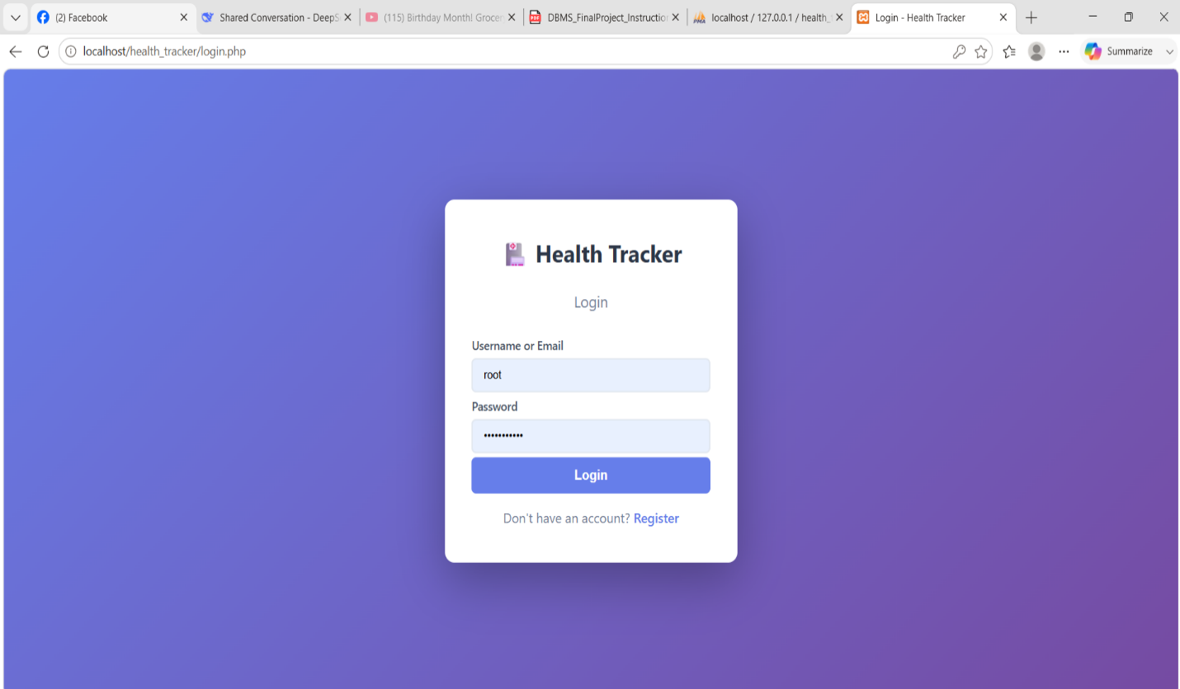
Figure 2. General Dashboard Page
The Dashboard provides the user with an at-a-glance overview of their health status and upcoming tasks, summarizing key metrics such as total vitals entries, active medications, and active goals; it displays the latest vital readings (blood pressure, heart rate, weight, blood sugar, temperature) with timestamps and a panel for upcoming medications so users can see imminent doses, and it highlights alerts or out-of-range values to prompt action, enabling quick daily checks, easier adherence management, and efficient preparation for clinician visits.
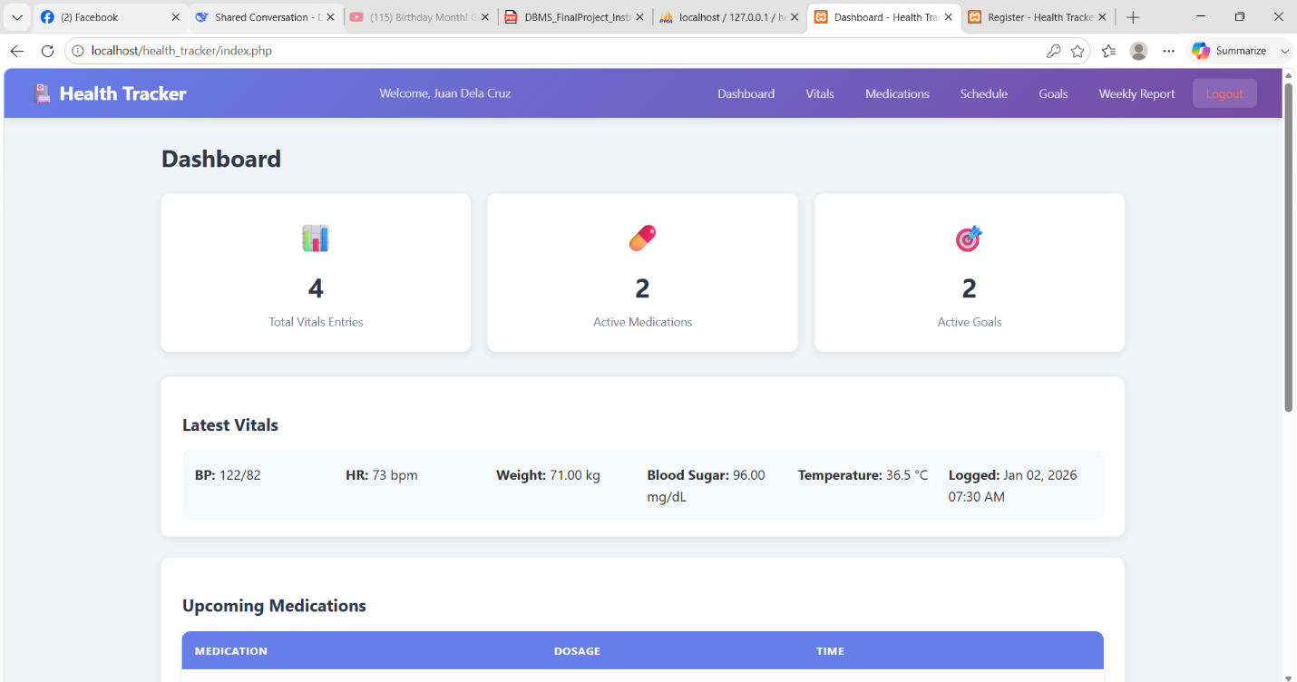

Figure 3. Medication and Recent Vitals Tables
The Medication and Recent Vitals Tables present a clear summary of the user s active medications with dosage and scheduled times alongside a chronological log of recent vital sign entries including blood pressure heart rate weight and blood sugar; this layout enables quick verification of dosing schedules, rapid review of recent measurements, and easy identification of trends or missed doses so users caregivers or clinicians can monitor adherence and health status efficiently.
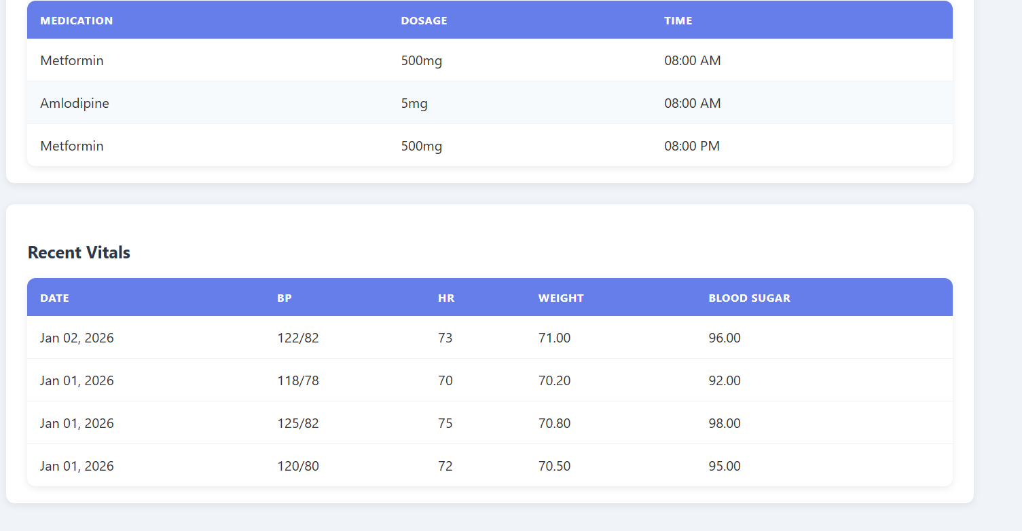

Figure 4. Medications Page
The Medications page lists active prescriptions with key details—name, dosage, frequency, start and end dates, prescribing doctor, and current status—and provides quick actions such as edit, delete, and mark taken; this layout helps users and caregivers manage medication regimens at a glance, verify dosing schedules, and update adherence while supporting easy addition of new medications and clear visibility of treatment timelines.
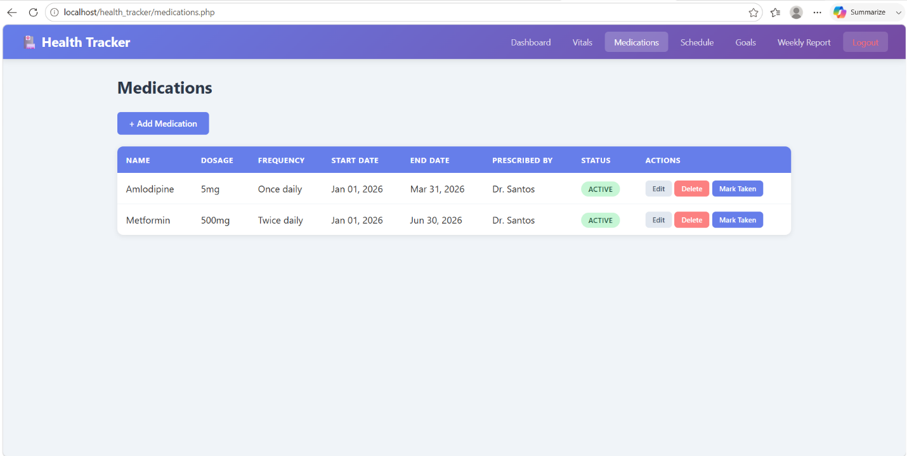
Figure 5. Medication Schedule Page
The Medication Schedule page lists upcoming doses with medication name, dosage, frequency, scheduled time, days, and current status, and provides quick actions such as marking a dose taken so users can verify daily schedules, track pending doses, and manage adherence at a glance.
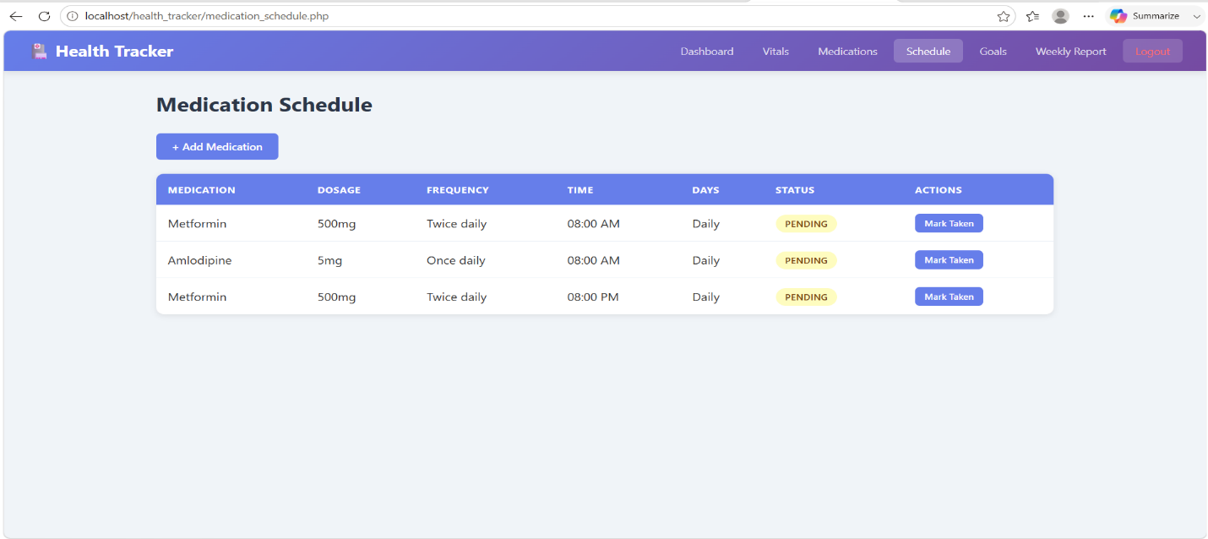
Figure 6. Set Health Goal Page
The Set Health Goal page provides a focused form for creating and tracking personal targets, with fields for Goal Type, Target Value, Current Value, Start Date, Target Date, Status, and Notes, plus Save Goal and Cancel actions; it guides users to define measurable objectives (for example weight or blood pressure), record baseline values, set timelines, and monitor progress so goals can be reviewed alongside vitals and medication adherence to support behavior change and clinician discussions.
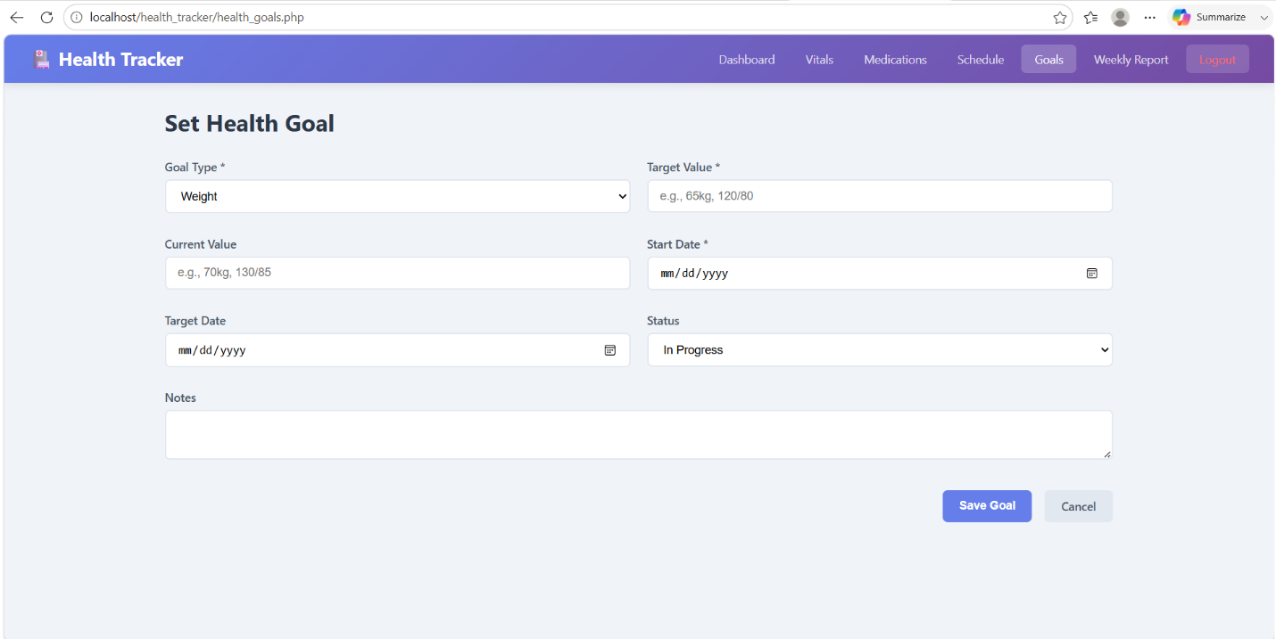
Figure 7. Weekly Health Report Page
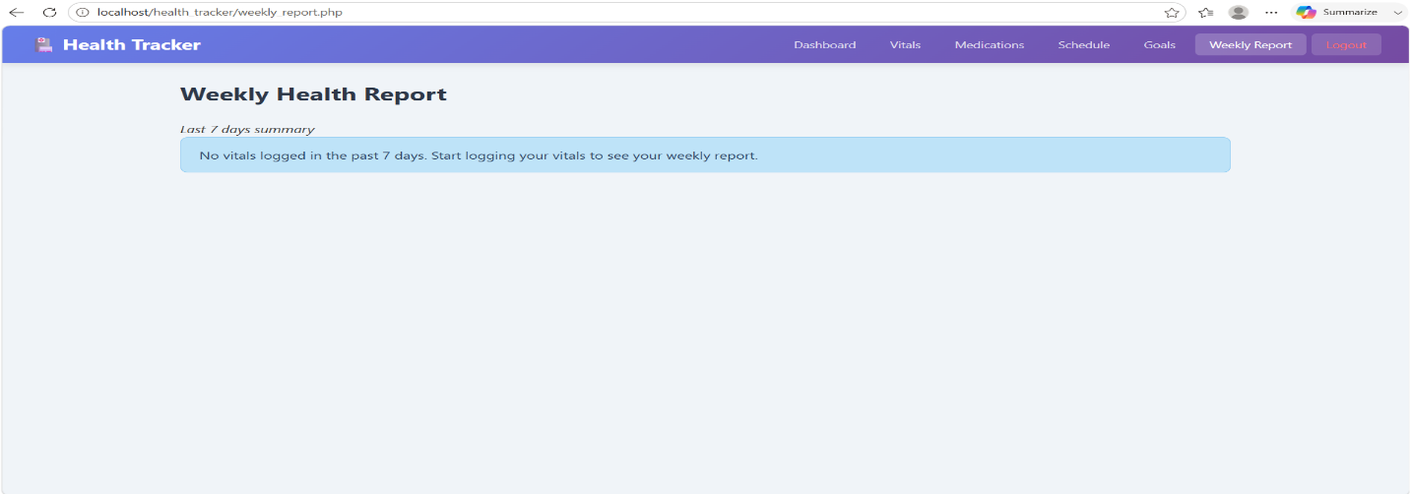
The Weekly Health Report page summarizes the user’s last seven days of activity and highlights gaps in monitoring; when no vitals have been recorded it displays a clear information message prompting the user to start logging readings, and when data is present the page compiles trends, adherence summaries, and alerts into a concise weekly overview to support self-management and clinician review.

Final Project | Section 7 – Individual Contribution Summary | DBSYS 1

1. Faith Wenchie C. Flor
Served as the lead backend developer and was primarily responsible for building the core functionality of the Personal Health and Medication Tracker System. Developed all PHP backend scripts including user authentication, CRUD operations for vitals logging, medication management, and health goals tracking. Implemented the medication scheduling and adherence marking features, including the logic to mark doses as taken or reset them. Designed and implemented the weekly report generation page with complex SQL queries using JOINs, aggregate functions, and subqueries for health trend analysis. Established the database connection and ensured secure session management across all pages. Also contributed to debugging, troubleshooting, and optimizing the overall system performance.

2. Jirah Joy E. Pardos
Handled the database design and architecture of the project. Created the Entity-Relationship Diagram (ERD) and carefully analyzed the system requirements to identify all necessary entities, attributes, and relationships including users, vitals_log, medications, medication_schedule, and health_goals. Defined all database tables with proper data types, primary keys, foreign keys, and constraints to ensure data integrity and consistency. Implemented the complete SQL script including stored procedures (LogVital and GetUserHealthSummary), the health_summary database view, and all seed data for testing. Conducted database testing and validation to ensure relationships and cardinalities were correctly established and all queries performed efficiently.

3. Dan Gero T. Villasor
Led the frontend development and quality assurance phase of the project. Designed and implemented the complete user interface using HTML5, CSS3, and JavaScript, including the responsive navigation system, dashboard layout, statistic cards, and all form pages. Created the CSS styling with gradient color schemes, card-based layouts, status badges, and mobile-responsive design. Wrote the JavaScript validation functions for login, registration, vitals, medications, and goals. Performed comprehensive testing on all major modules including login, vitals logging, medication management, health goals, and weekly reporting features. Verified that all calculations, validations, search functions, and user restrictions operated correctly under different scenarios. Identified bugs and system errors during testing and assisted in implementing fixes to ensure the final system met all functional requirements.

